Excercise: Anti-apoptotic survival signaling
1) Distinctive features of apoptosis
a. Several assays exist to distinguish apoptotic cells from other dying cells. What characteristic feature is detected by each of the following techniques:
- Agarose gel electrophoresis:
- Annexin V staining:
- Caspase-3 immunostaining:
- TUNEL assay:
- Why is it advantageous for multicellular organisms to eliminate supernumerary cells by apoptosis rather than by specific necrosis-inducing factors?
- What factors regulate the clearance of debris from apoptotic cells by phagocytes?

2) Which of these statements about survival signaling and its deregulation in cancer cells is true:
A. It involves numerous effects of AKT, including the downregulation of mTORC2
B. No cell survival signals mediated by mTORC1 are altered in cancer cells treated by rapalogs
C. It plays a key role in tumor recurrence after chemotherapy
D. It is facilitated by the loss of cell attachment to the ECM
E. It relies on the ability of cancer cells to adhere to one another via specific integrins

3) Role of apoptosis and its suppression in cancer
- At what stage(s) of tumor progression or during the invasion & metastasis cascade are oncogenic cell survival signals essential?
- How does apoptosis and its evasion by oncogenic cell survival signals influence the response to chemo- or radiotherapy?
- From the Weinberg textbook: In a study of 35 primary lung and colon tumors, half of the tumors amplified and overexpressed a gene for a secreted protein that sequesters the ligand of Fas. How do you expect this protein to affect tumor surveillance by the immune system?

4) "Application": Therapeutic inhibition of survival signaling
- The first generation of mTOR inhibitors including Sirolimus (Rapamycin) and related “rapalogs” only partially inhibit mTORC1, but not mTORC2. Considering the schema of mTOR signaling regulation below, how can one explain that rapalogs nevertheless tend to increase cancer cell survival signaling by mTOR rather than blocking it?
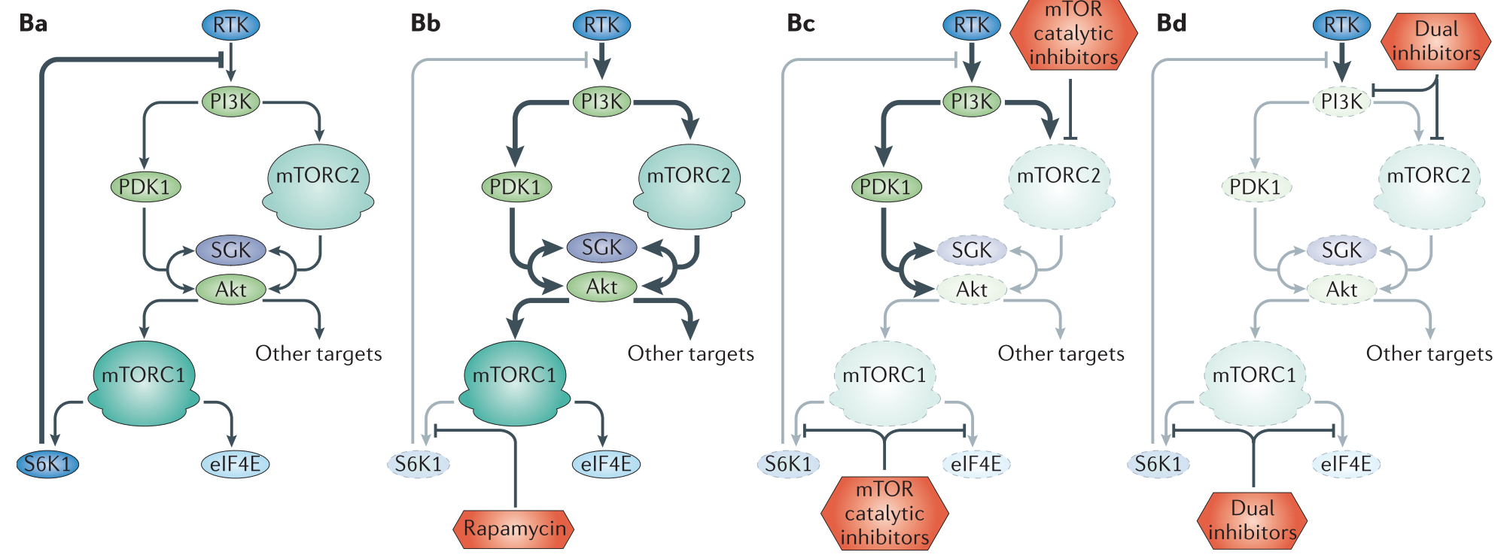

- What would you expect to be the advantages and potential disadvantages of the second generation mTOR inhibitors in panels Bc and Bd?

5) Regulation of apoptosis
Cultured skin cells from three patients (X, Y, Z) were exposed to strong UV radiation. Subsequent monitoring in culture revealed that these UV-irradiated cells behaved as follows:
Hours after UV | X | Y | Z
24 | Alive | Alive | Apoptotic
48 | Necrotic;  cytosol contains cytochrome C and other mitochondrial proteins; no active Casp3 | Alive;  no mitochondrial proteins in the cytosol; no active caspases
96 |  | Alive

a. What molecular defects would explain the transient and the complete resistance to UV radiation in X or Y cells, respectively? In other words, what alterations in apoptotic signal transduction proteins could account for the X and Y cell phenotypes? Hint: Use the maps of known cell death signaling pathways, e.g. on slides 16 and 42-46.
b. After UV treatment, the cells from patient X eventually still died, but by necrosis (i.e. independently of apoptosis) and only after a delay of 48 hrs. How do you explain this outcome?

